# **Tomcat service Upgradation on Linux server.**

**Assumptions**

This article assumes you have an existing server (real or virtual) with Tomcat installed on it.

Here are the steps to upgrade Tomcat Services:

1. Download Tomcat latest version from <https://tomcat.apache.org/download-90.cgi>.

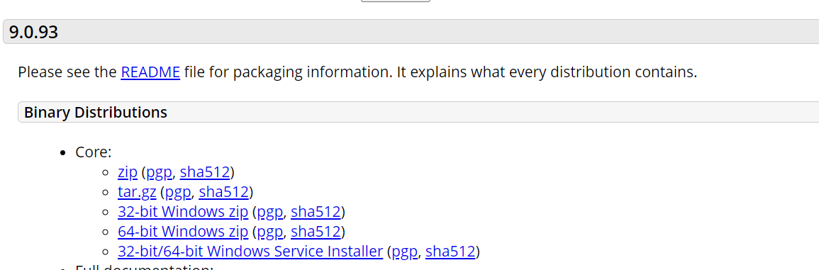

1. Grep the tomcat service and check the path where the tomcat is installed.

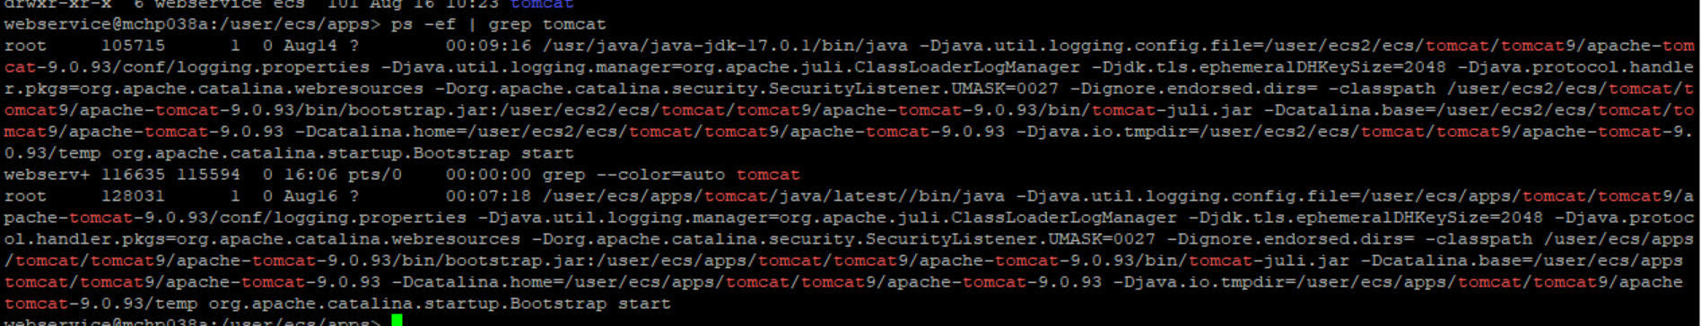

1. Route the path.

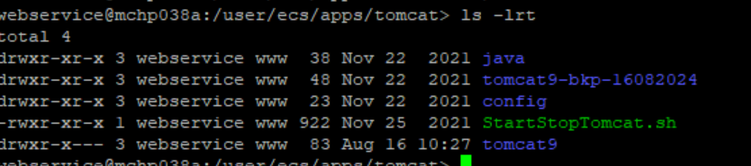

1. Backup the running tomcat file and copy the latest tomcat to this folder.
2. Untar the tomcat.tar file and create a soft link for the untared folder.

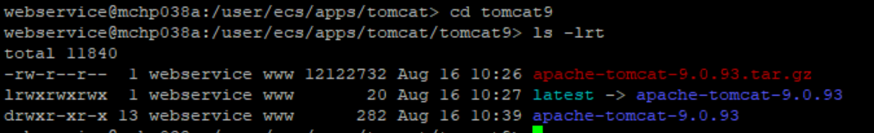

1. Backup the new conf, webapps and work folder and copy these files from old tomcat folder to new. Also copy ssl folder from old to new.

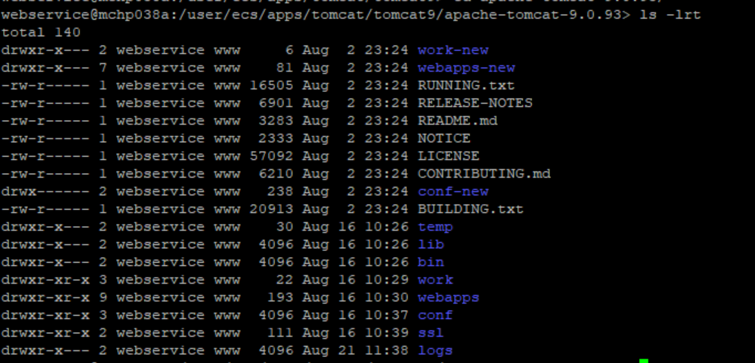

1. Enable java by executing these sudo codes.

echo 'export JAVA_HOME=/user/ecs/apps/tomcat/java/latest/' >> ~/.bashrc

echo 'export JRE_HOME=$JAVA_HOME' >> ~/.bashrc

source ~/.bashrc

1. Navigate to bin path and execute shutdown.sh.

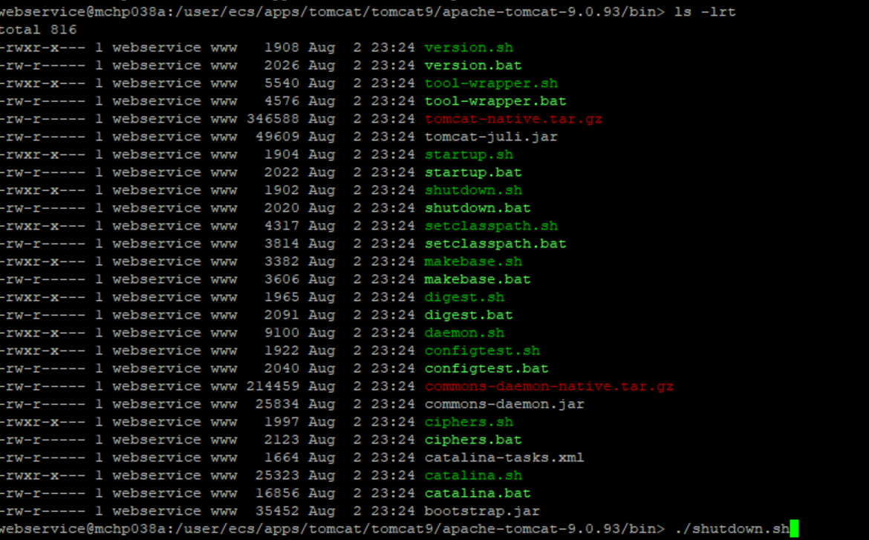

1. Now start the tomcat services by executing startup.sh.

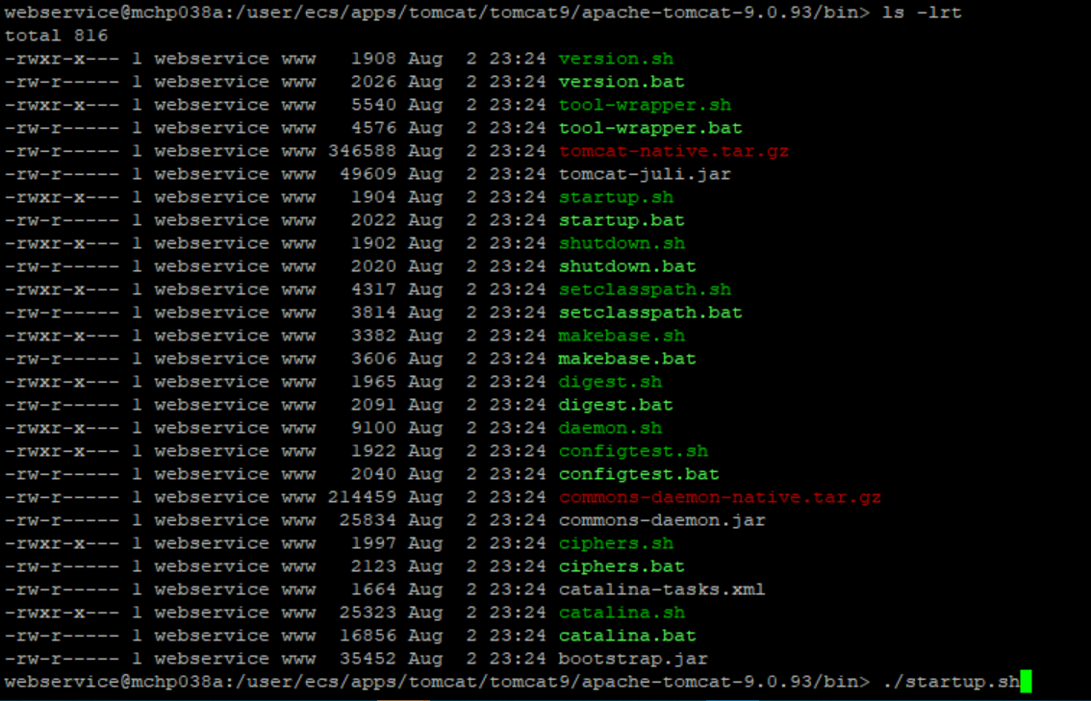

1. Now check the port number from server.xml

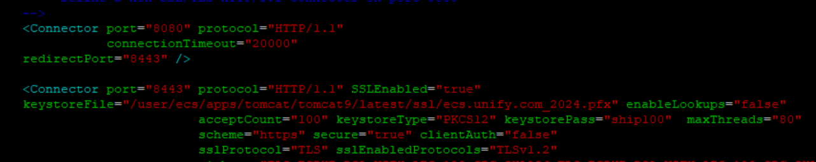

1. Hit the url and check whether it is reflected or not.

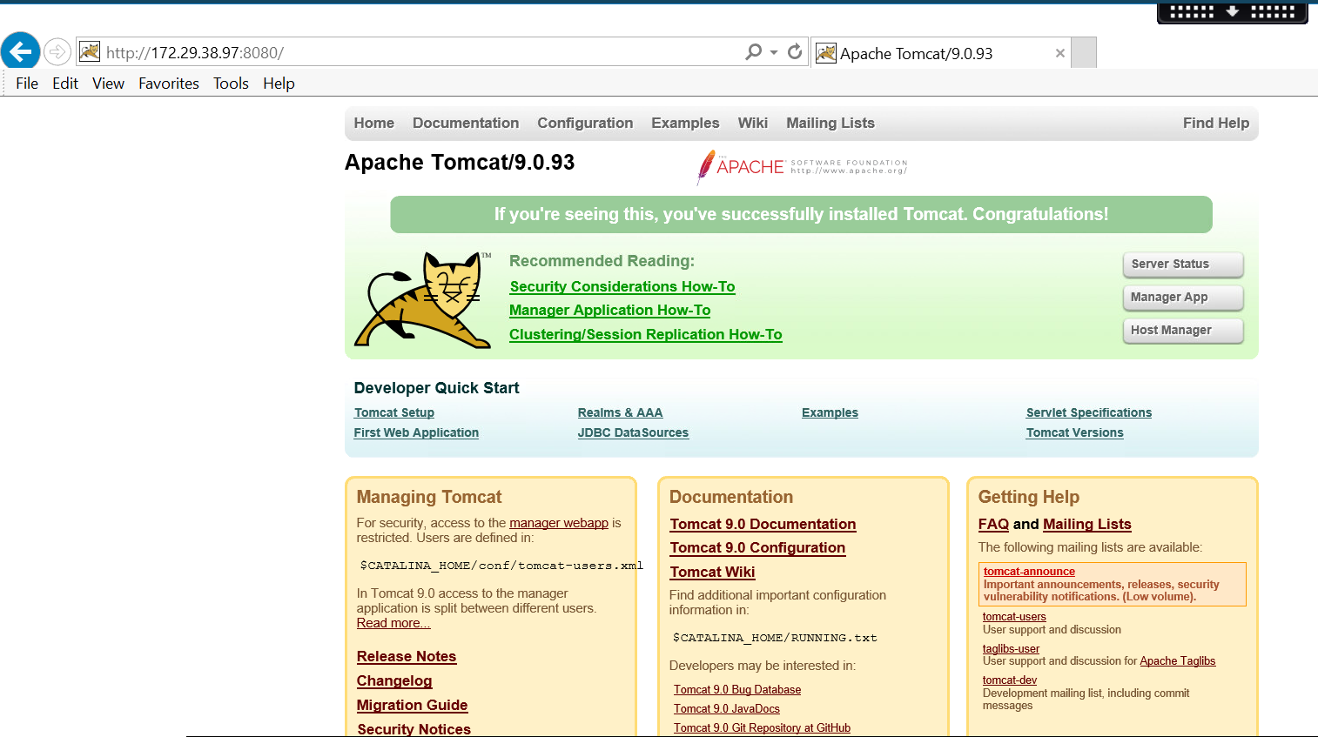

1. Now the tomcat is upgraded.